**FINGER PRINT BASED ELECTRONIC VOTING MACHINE**

It has always been an arduous task for the election commission to conduct free and fair polls in our country, the largest democracy in the world. Crores of rupees have been spent on this to make sure that the elections are riot free. But, now- a -days it has become common for some forces to indulge in rigging which may eventually lead to a result contrary to the actual verdict given by the People

This paper aims to present a new voting system employing biometrics in order to avoid rigging and to enhance the accuracy and speed of the process. The system uses thumb impression for voter identification as we know that the thumb impression of every human being has a unique pattern. Thus it would have an edge over the present day voting systems.

As a pre-poll procedure, a database consisting of the thumb impressions of all the eligible voters in a constituency is created. During elections, the thumb impression of a voter is entered as input to the system. This is then compared with the available records in the database. If the particular pattern matches with anyone in the available record, access to cast a vote is granted. But in case the pattern doesn’t match with the records of the database or in case of repetition, access to cast a vote is denied or the vote gets rejected.

**BLOCK DIAGRAM**

BUZZER

LCD DISPLAY

KEYPAD TO CAST VOTE

ARDUINO UNO

RESULT BUTTON

R307 FINGURE PRINT SENSOR

Arduino UNO

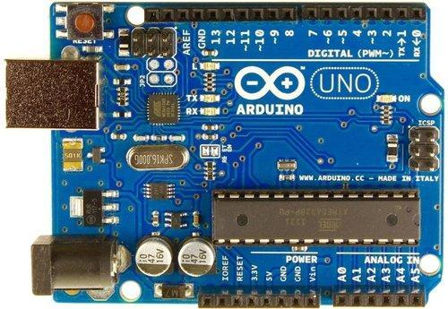

**Arduino Uno** is a microcontroller board based on the ATmega328P ([datasheet](http://ww1.microchip.com/downloads/en/DeviceDoc/Atmel-7810-Automotive-Microcontrollers-ATmega328P_Datasheet.pdf)). It has 14 digital input/output pins (of which 6 can be used as PWM outputs), 6 analog inputs, a 16 MHz ceramic resonator (CSTCE16M0V53-R0), a USB connection, a power jack, an ICSP header and a reset button

**General pin functions**

* LED: There is a built-in LED driven by digital pin 13. When the pin is high value, the LED is on, when the pin is low, it is off.
* VIN: The input voltage to the Arduino/Genuino board when it is using an external power source (as opposed to 5 volts from the USB connection or other regulated power source). You can supply voltage through this pin, or, if supplying voltage via the power jack, access it through this pin.
* 5V: This pin outputs a regulated 5V from the regulator on the board. The board can be supplied with power either from the DC power jack (7 - 20V), the USB connector (5V), or the VIN pin of the board (7-20V). Supplying voltage via the 5V or 3.3V pins bypasses the regulator, and can damage the board.
* 3V3: A 3.3 volt supply generated by the on-board regulator. Maximum current draw is 50 mA.
* GND: Ground pins.
* IOREF: This pin on the Arduino/Genuino board provides the voltage reference with which the microcontroller operates. A properly configured shield can read the IOREF pin voltage and select the appropriate power source, or enable voltage translators on the outputs to work with the 5V or 3.3V.
* Reset: Typically used to add a reset button to shields that block the one on the board.

**Special pin functions**

Each of the 14 digital pins and 6 analog pins on the Uno can be used as an input or output, under software control (using pinMode(), digitalWrite(), and digitalRead() functions). They operate at 5 volts. Each pin can provide or receive 20 mA as the recommended operating condition and has an internal pull-up resistor (disconnected by default) of 20-50K ohm. A maximum of 40mA must not be exceeded on any I/O pin to avoid permanent damage to the microcontroller. The Uno has 6 analog inputs, labeled A0 through A5; each provides 10 bits of resolution (i.e. 1024 different values). By default, they measure from ground to 5 volts, though it is possible to change the upper end of the range using the AREF pin and the analogReference() function.

In addition, some pins have specialized functions:

* Serial / [UART](https://en.wikipedia.org/wiki/UART): pins 0 (RX) and 1 (TX). Used to receive (RX) and transmit (TX) TTL serial data. These pins are connected to the corresponding pins of the ATmega8U2 USB-to-TTL serial chip.
* External interrupts: pins 2 and 3. These pins can be configured to trigger an interrupt on a low value, a rising or falling edge, or a change in value.
* [PWM](https://en.wikipedia.org/wiki/Pulse-width_modulation) (pulse-width modulation): pins 3, 5, 6, 9, 10, and 11. Can provide 8-bit PWM output with the analogWrite() function.
* [SPI](https://en.wikipedia.org/wiki/Serial_Peripheral_Interface) (Serial Peripheral Interface): pins 10 (SS), 11 (MOSI), 12 (MISO), and 13 (SCK). These pins support SPI communication using the SPI library.
* TWI (two-wire interface) / [I²C](https://en.wikipedia.org/wiki/I%C2%B2C): pin SDA (A4) and pin SCL (A5). Support TWI communication using the Wire library.
* AREF (analog reference): Reference voltage for the analog inputs.

# SPST Momentary Push Button

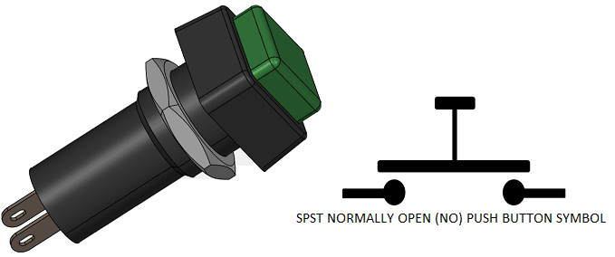

Push buttons are used in applications which requires momentary ON or OFF switching action. Normally Open Push button switch are initially in OFF state as the contacts are not in contact with each and when pushed down the contacts gets closed and the path established between the two terminals of the push button.

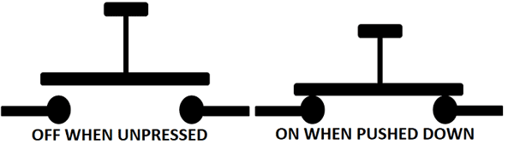

**16*2 LCD Display**

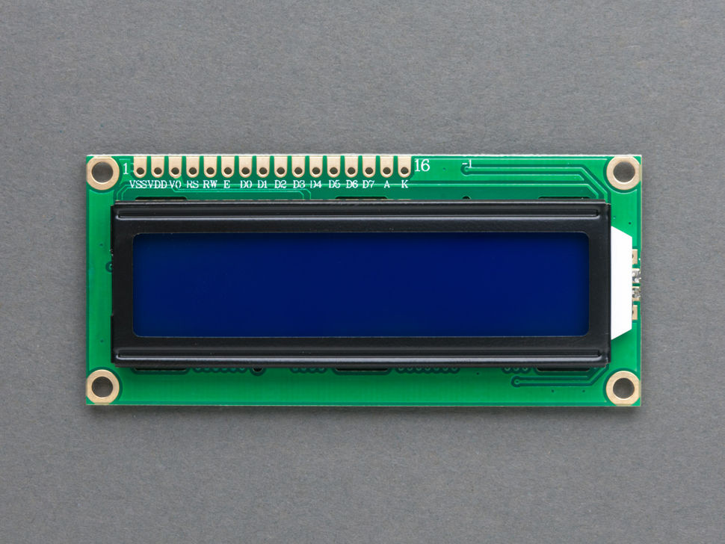

An LCD (Liquid Crystal Display) screen is an electronic display module and has a wide range of applications. A 16x2 LCD display is very basic module and is very commonly used in various devices and circuits. A 16x2 LCD means it can display 16 characters per line and there are 2 such lines. In this LCD each character is displayed in 5x7 pixel matrix. The 16 x 2 intelligent alphanumeric dot matrix display is capable of displaying 224 different characters and symbols. This LCD has two registers, namely, Command and Data.

Command register stores various commands given to the display. Data register stores data to be displayed. The process of controlling the display involves putting the data that form the image of what you want to display into the data registers, then putting instructions in the instruction register. In your arduino project [Liquid Crystal Library](https://www.arduino.cc/en/Reference/LiquidCrystal) simplifies this for you so you don't need to know the low-level instructions. Contrast of the display can be adjusted by adjusting the potentiometer to be connected across VEE pin.

|  |  |  |
| --- | --- | --- |
| **Pin number** | **name** | **Description** |
| 1 | Ground/Source Pin | This is a GND pin of display, used to connect the GND terminal of the microcontroller unit or power source. |
| 2 | VCC/Source Pin | This is the voltage supply pin of the display, used to connect the supply pin of the power source. |
| 3 | V0/VEE/Control Pin | Adjusts the contrast of the LCD. |
| 4 | Register Select | This pin toggles among command or data register, used to connect a microcontroller unit pin and obtains either 0 or 1(0 = data mode, and 1 = command mode). |
| 5 | Read/Write/Control Pin | This pin toggles the display among the read or writes operation, and it is connected to a microcontroller unit pin to get either 0 or 1 (0 = Write Operation, and 1 = Read Operation). |
| 6 | Enable/Control Pin | This pin should be held high to execute Read/Write process, and it is connected to the microcontroller unit & constantly held high. |
| 7 to 14 | Data Pins | These pins are used to send data to the display. These pins are connected in two-wire modes like 4-wire mode and 8-wire mode. In 4-wire mode, only four pins are connected to the microcontroller unit like 0 to 3, whereas in 8-wire mode, 8-pins are connected to microcontroller unit like 0 to 7. |
| 15 | +ve pin of the LED | This pin is connected to +5V |
| 16 | -ve pin of the LED | This pin is connected to GND. |

**R307 figure print Sensor**

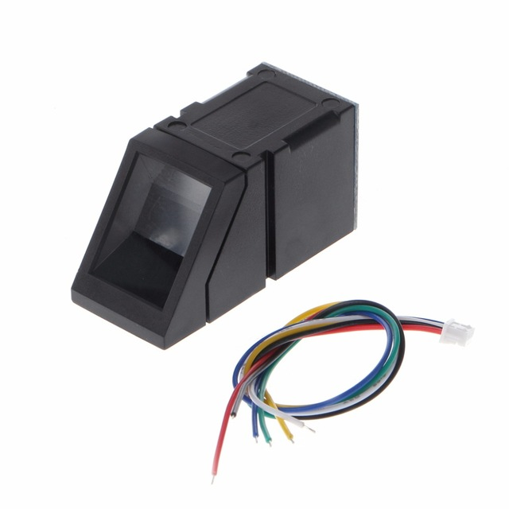

R307 Fingerprint Module consists of optical fingerprint sensor, high-speed DSP processor, high-performance fingerprint alignment algorithm, high-capacity FLASH chips and other hardware and software composition, stable performance, simple structure, with fingerprint entry, image processing, fingerprint matching, search and template storage and other functions.

**Features**

* Perfect function: independent fingerprint collection, fingerprint registration, fingerprint comparison (1: 1) and fingerprint search (1: N) function.
* Small size: small size, no external DSP chip algorithm, has been integrated, easy to install, less fault.
* Ultra-low power consumption: low power consumption of the product as a whole, suitable for low-power requirements of the occasion.
* Anti-static ability: a strong anti-static ability, anti-static index reached 15KV above.
* Application development is simple: developers can provide control instructions, self-fingerprint application product development, without the need for professional knowledge of fingerprinting.
* Adjustable security level: suitable for different applications, security levels can be set by the user to adjust.
* Finger touch sensing signal output, low effective, sensing circuit standby current is very low, less than 5uA.

**Interface Description**

The R307 fingerprint module has two interface TTL UART and USB2.0, USB2.0 interface can be connected to the computer; RS232 interface is a TTL level, the default baud rate is 57600 , can be changed, refer to a communication protocol ; can And microcontroller, such as ARM, DSP and other serial devices with a connection, 3.3V 5V microcontroller can be connected directly. Needs to connect the computer level conversion, level conversion note , embodiments such as a MAX232 circuit.

**About the module's power supply**

     Fingerprint module board marked with 3.3V - 2 contacts short circuit, you can use DC3.3V .